BLOGER INSTALLATION STEPS:

Installer Requirements:

[1] Computer Unit Framework must be Version 3.5, if not browse the component folder then install [Microsoft .NET Framework 3.5_dotnetfx35]

[2] Install CRRedist_2008_x86 to view and generate reports.

[3] Configure ODBC to Connect Report on Server

To configure ODBC just follow the steps below

[A]

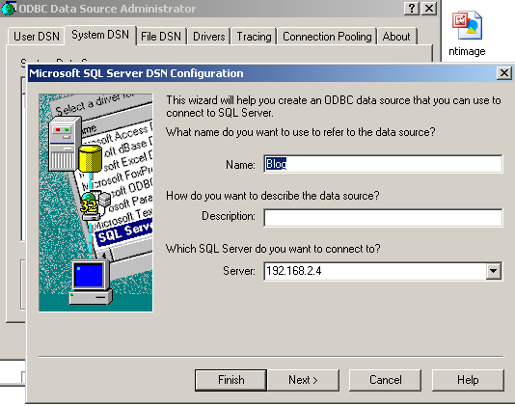

[B]

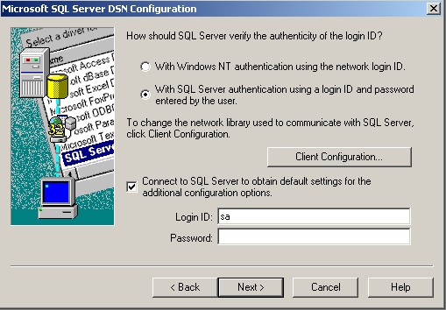

[C]

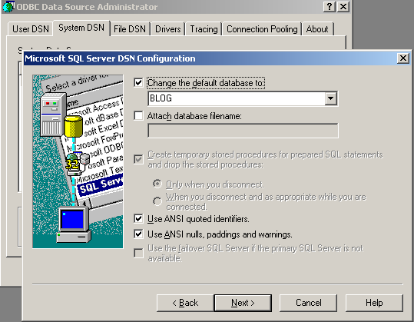

[4]. Now Go to Release Folder then click Setup to Install the BLOGERS, just click next > next > next